Android Lab Record
CYCLE 1

Anunadh Rajesh
20MCA015
S3MCA

1.) Design a Login page

xml

<LinearLayout android:layout_width="match_parent"
android:layout_height="match_parent"
android:orientation="vertical"
xmlns:android="http://schemas.android.com/apk/res/android">
<TextView
android:layout_width="match_parent"
android:layout_height="wrap_content"
android:text="LOGIN"
android:textAlignment="center"
android:textSize="30dp"
android:textStyle="bold"
android:layout_marginTop="40dp"
android:id="@+id/t1"/>
<TextView
android:layout_width="match_parent"
android:layout_height="wrap_content"
android:text="Username:"
android:textSize="20dp"
android:layout_marginLeft="28dp"
android:layout_marginTop="17dp"
android:id="@+id/t2"/>
<EditText
android:id="@+id/e1"
android:layout_width="300dp"
android:layout_height="wrap_content"
android:hint="Enter your name"
android:layout_marginLeft="24dp"
android:layout_marginTop="10dp"/>
<TextView
android:id="@+id/t3"
android:layout_width="match_parent"
android:layout_height="wrap_content"
android:text="Password:"
android:textSize="20dp"
android:layout_marginLeft="28dp"
android:layout_marginTop="10dp"
/>
<EditText
android:id="@+id/e2"
android:layout_width="300dp"
android:layout_height="wrap_content"
android:hint="Enter the Password"
android:layout_marginLeft="24dp"
android:layout_marginTop="10dp"/>
<Button
android:layout_width="200dp"
android:layout_height="wrap_content"
android:layout_marginLeft="90dp"
android:layout_marginTop="24dp"
android:background="@android:color/holo_blue_dark"
android:text="SUBMIT"
android:textColor="#fffafa"
android:textSize="20dp"
android:textStyle="bold" />
</LinearLayout>

OUTPUT

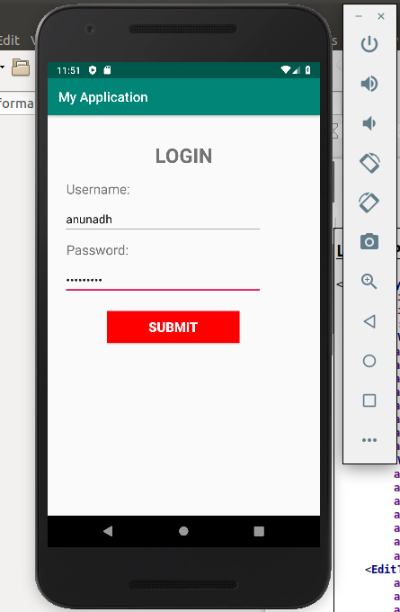

2.) Change the content in the text view on a button click.

xml

<LinearLayout xmlns:android="http://schemas.android.com/apk/res/android"
android:layout_width="match_parent"
android:layout_height="match_parent"
android:orientation="vertical">
<EditText
android:layout_width="match_parent"
android:layout_height="wrap_content"
android:hint="Enter your Name"
android:id="@+id/et1"/>
<TextView
android:layout_width="match_parent"
android:layout_height="wrap_content"
android:text=""
android:textColor="#000000"
android:layout_marginLeft="175dp"
android:id="@+id/tv1"/>
<Button
android:layout_width="match_parent"
android:layout_height="wrap_content"
android:text="Click Here"
android:background="#32cd32"
android:textColor="#3f76ff"
android:id="@+id/btn1"
android:onClick="Click"/>
</LinearLayout>

java

package com.example.sjcet.gdmrg;
import android.support.v7.app.AppCompatActivity;
import android.os.Bundle;
import android.view.View;
import android.widget.TextView;
public class MainActivity extends AppCompatActivity {
@Override
protected void onCreate(Bundle savedInstanceState) {
super.onCreate(savedInstanceState);
setContentView(R.layout.activity_main);
}
public void Click(View view) {
((TextView)findViewById(R.id.tv1)).setText("Good Night");
}
}

OUTPUT
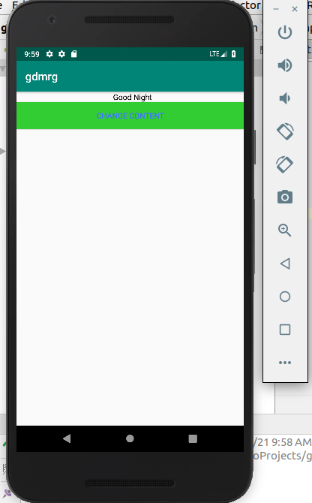
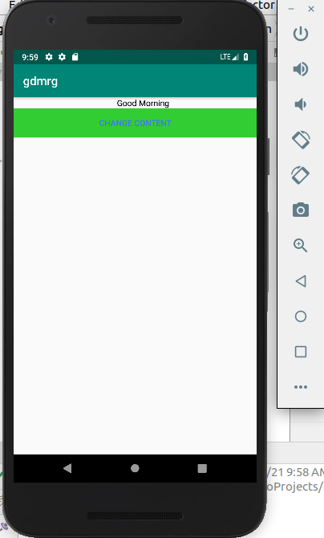

3.) Read a content from edit test and print it in text view.

Xml

<LinearLayout xmlns:android="http://schemas.android.com/apk/res/android"
android:layout_width="match_parent"
android:layout_height="match_parent"
android:orientation="vertical">
<EditText
android:layout_width="match_parent"
android:layout_height="wrap_content"
android:hint="Enter your Name"
android:id="@+id/et1"/>
<TextView
android:layout_width="match_parent"
android:layout_height="wrap_content"
android:text=""
android:textColor="#000000"
android:layout_marginLeft="175dp"
android:id="@+id/tv1"/>
<Button
android:layout_width="match_parent"
android:layout_height="wrap_content"
android:text="Click Here"
android:background="#32cd32"
android:textColor="#3f76ff"
android:id="@+id/btn1"
android:onClick="Click"/>
</LinearLayout>
java

package com.example.sjcet.textview;
import android.support.v7.app.AppCompatActivity;
import android.os.Bundle;
import android.view.View;
import android.widget.EditText;
import android.widget.TextView;
public class MainActivity extends AppCompatActivity {
@Override
protected void onCreate(Bundle savedInstanceState) {
super.onCreate(savedInstanceState);
setContentView(R.layout.activity_main);
}
public void Click(View view) {
EditText edit = (EditText)findViewById(R.id.et1);
TextView tview = (TextView)findViewById(R.id.tv1);
String result = edit.getText().toString();
tview.setText(result);
}
}

OUTPUT

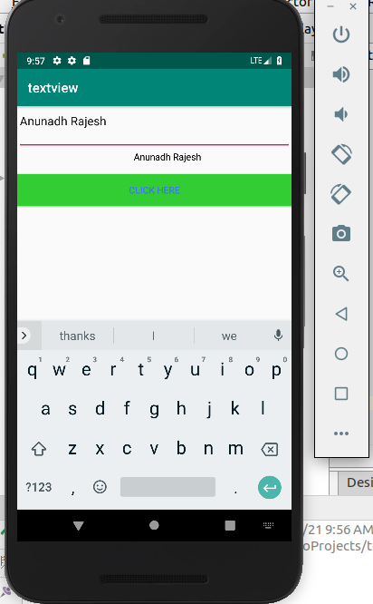

4.) Change the background colour on a button click.

Xml

<LinearLayout xmlns:android="http://schemas.android.com/apk/res/android"
android:layout_width="match_parent"
android:layout_height="match_parent"
android:orientation="vertical"
android:background="#191970"
android:id="@+id/ll1">
<Button
android:layout_width="match_parent"
android:layout_height="wrap_content"
android:text="Click Here"
android:background="#32cd32"
android:textColor="#3f76ff"
android:id="@+id/btn1"
android:onClick="Click"/>
</LinearLayout>

Java

package com.example.sjcet.background;
import android.graphics.Color;
import android.support.v7.app.AppCompatActivity;
import android.os.Bundle;
import android.view.View;
import android.widget.LinearLayout;
public class MainActivity extends AppCompatActivity {
@Override
protected void onCreate(Bundle savedInstanceState) {
super.onCreate(savedInstanceState);
setContentView(R.layout.activity_main);
}
public void Click(View view) {
LinearLayout layout1;
layout1 = findViewById(R.id.ll1);
layout1.setBackgroundColor(Color.RED);
}
}

OUTPUT

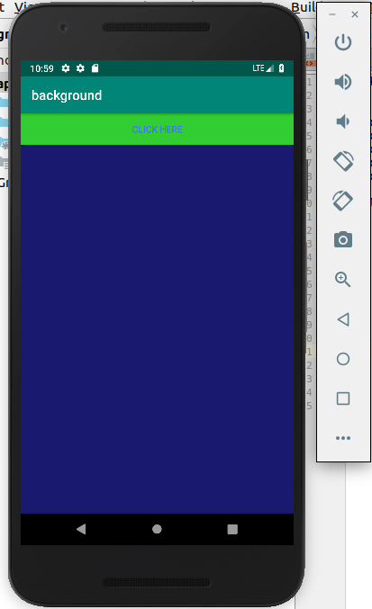
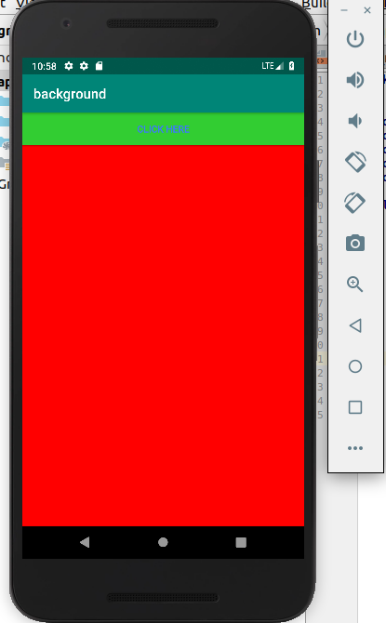

5.) Create a Sample Calculator.

Xml

<?xml version="1.0" encoding="utf-8"?>
<LinearLayout
xmlns:android="http://schemas.android.com/apk/res/android"
android:orientation="vertical"
android:layout_width="fill_parent"
android:layout_height="fill_parent">
<LinearLayout
android:layout_width="match_parent"
android:layout_height="wrap_content"
android:id="@+id/linearLayout1"
android:layout_marginLeft="10pt"
android:layout_marginRight="10pt"
android:layout_marginTop="3pt">
<EditText
android:layout_weight="1"
android:layout_height="wrap_content"
android:layout_marginRight="5pt"
android:id="@+id/etNum1"
android:layout_width="match_parent"
android:inputType="numberDecimal">
</EditText>
<EditText
android:layout_height="wrap_content"
android:layout_weight="1"
android:layout_marginLeft="5pt"
android:id="@+id/etNum2"
android:layout_width="match_parent"
android:inputType="numberDecimal">
</EditText>
</LinearLayout>
<LinearLayout
android:layout_width="match_parent"
android:layout_height="wrap_content"
android:id="@+id/linearLayout2"
android:layout_marginTop="3pt"
android:layout_marginLeft="5pt"
android:layout_marginRight="5pt">
<Button
android:layout_height="wrap_content"
android:layout_width="match_parent"
android:layout_weight="1"
android:text="+"
android:textSize="8pt"
android:id="@+id/btnAdd">
</Button>
<Button
android:layout_height="wrap_content"
android:layout_width="match_parent"
android:layout_weight="1"
android:text="-"
android:textSize="8pt"
android:id="@+id/btnSub">
</Button>
<Button
android:layout_height="wrap_content"
android:layout_width="match_parent"
android:layout_weight="1"
android:text="*"
android:textSize="8pt"
android:id="@+id/btnMult">
</Button>
<Button
android:layout_height="wrap_content"
android:layout_width="match_parent"
android:layout_weight="1"
android:text="/"
android:textSize="8pt"
android:id="@+id/btnDiv">
</Button>
</LinearLayout>
<TextView
android:layout_height="wrap_content"
android:layout_width="match_parent"
android:layout_marginLeft="5pt"
android:layout_marginRight="5pt"
android:textSize="12pt"
android:layout_marginTop="3pt"
android:id="@+id/tvResult"
android:gravity="center_horizontal">
</TextView>
</LinearLayout>

Java

package com.example.sjcet.calculator;
import android.app.Activity;
import android.os.Bundle;
import android.text.TextUtils;
import android.view.View;
import android.widget.Button;
import android.widget.EditText;
import android.widget.TextView;
public class MainActivity extends Activity implements View.OnClickListener {
EditText etNum1;
EditText etNum2;
Button btnAdd;
Button btnSub;
Button btnMult;
Button btnDiv;
TextView tvResult;
String oper = "";

@Override
public void onCreate(Bundle savedInstanceState) {
super.onCreate(savedInstanceState);
setContentView(R.layout.activity_main);
// find the elements
etNum1 = (EditText) findViewById(R.id.etNum1);
etNum2 = (EditText) findViewById(R.id.etNum2);
btnAdd = (Button) findViewById(R.id.btnAdd);
btnSub = (Button) findViewById(R.id.btnSub);
btnMult = (Button) findViewById(R.id.btnMult);
btnDiv = (Button) findViewById(R.id.btnDiv);
tvResult = (TextView) findViewById(R.id.tvResult);
// set a listener
btnAdd.setOnClickListener(this);
btnSub.setOnClickListener(this);
btnMult.setOnClickListener(this);
btnDiv.setOnClickListener(this);
}
@Override
public void onClick(View v) {
// TODO Auto-generated method stub
float num1 = 0;
float num2 = 0;
float result = 0;

if (TextUtils.isEmpty(etNum1.getText().toString())
|| TextUtils.isEmpty(etNum2.getText().toString())) {
return;
}

num1 = Float.parseFloat(etNum1.getText().toString());
num2 = Float.parseFloat(etNum2.getText().toString());

switch (v.getId()) {
case R.id.btnAdd:
oper = "+";
result = num1 + num2;
break;
case R.id.btnSub:
oper = "-";
result = num1 - num2;
break;
case R.id.btnMult:
oper = "*";
result = num1 * num2;
break;
case R.id.btnDiv:
oper = "/";
result = num1 / num2;
break;
default:
break;
}

tvResult.setText(num1 + " " + oper + " " + num2 + " = " + result);
}
}
